PLEASE SCAN THIS QR CODE TO JOIN OUR FACEBOOK PAGE
BOSVENA AND THREE HARBOURS DIABETES TEAM

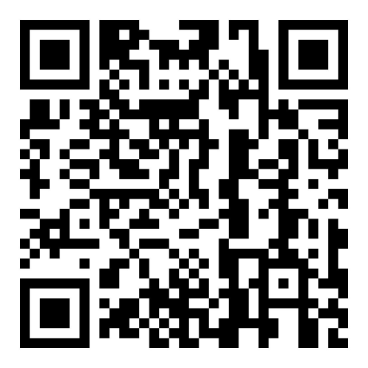
Or send us an email to request access and we can invite you that way

Bosvena3harbours.diabetesteam@nhs.net

